(PATIENT TO KEEP LAST TWO PAGES, RETURN THIS PAGE)
Manage My Health Consent and Registration Form

Please print CLEARLY – Patient must be 16+ years

IMPORTANT
Each family member needs their own individual email address.
Please write CLEARLY to avoid a delay in the registration process
Name:
Address:
Date of Birth
Email Address:
Previously Registered to Manage My Health

Name of Previous Medical Centre ___________________________________

Photo identification attached (Drivers Licence/Valid Passport/Student ID or 18+Card)

I have read and agree to the patient portal terms and conditions

Patient signature: _________________________ Todays date: __________

OFFICE USE AND REFERENCE GUIDE

- Patient has read terms and conditions. And has signed and dated consent form
- Process within 1 – 2 days
- All processed and non-processed forms to go in folder. YOU MUST ONLY SCAN form once activation and verification process has been completed.

- MMH VERIFICATION STAGE (patient not completed)  TXT ONE Date: _________________  TXT TWO Date: _________________  Move to Final MMH Stage | - MMH FINAL STAGE (patient not completed or non-compliant)  - Daily record entered and checklist updated  - Scan form to medtech and file under corresponding patient.

WELCOME Nau mai haere mai

ManageMyHealth is a secure website which uploads your information from your general practice computer so that you can access it online 24/7 from your computer or smartphone.

For Naenae Medical Center it is a way to have secure electronic communication with you, which can help you manage your health better and help us manage the day to day running of our practice.

SERVICES INCLUDE:

- Ordering repeat routine prescriptions
- Booking Appointments
- Access to clinician/consult notes (from 1st October 2019)
- Access to results and recalls
- Communicating with your GP and Practice Team
- Option to use an APP on your mobile
IMPORTANT
We CAN activate your account on your behalf and in turn you will receive an email from Manage My Health, and within that will be a link. Once you have clicked into the link the message that you have successfully registered will be on screen. You will then be able to visit the website and securely log in using your email address. For this, YOU MUST SPEAK TO OUR ADMIN TEAM ABOUT ACTIVATING YOUR ACCOUNT

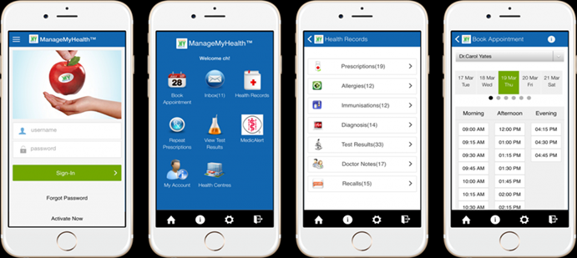
FOR MOBILE FRIENDLY USEAGE – DOWNLOAD THE MANAGEMYHEALTH APP TODAY

TERMS AND CONDITIONS
Repeat prescription requests
PLEASE NOTE:
- This is a 48hr service for non-urgent and routine prescriptions that have been issued by Naenae Medical Centre.
Once your request has been processed an email will be sent to your ManageMyHealth account to advise you if your request has been accepted or rejected. If your request has been rejected you will need to contact Naenae Medical Centre on (04)5671066 and make an appointment to see your doctor.

Prescription Charges:
- Repeat Prescription = $10.00 to $20
- If faxed an additional $5 will be added to the total cost of your prescription
Faxed Prescription – please advise which pharmacy you wish your script to be faxed to.
PAYMENT OPTIONS
Online payments preferred.
Account Name: Naenae Medical Centre
Account Number: 01-0530-0345217-00
Reference: Use your first and last name as a reference (so your payment can be allocated correctly)

Collection of Prescriptions and Payment:
Cash or Eftpos payment is to be made on the day you collect your prescription
Lab test results
We would like to use ManageMyHealth as the main way of notifying you of your test results. This is a NON URGENT SERVICE and we will try to have your results available within 2 working days of the results being received into our system. If we need to talk to you about your results, we will try to contact you by phone in the first instance. If we cannot reach you by phone we will send a txt message, email or letter. If you have an urgent query, please ring the practice on (04)5671066
Appointments
PLEASE DO NOT BOOK URGENT APPOINTMENTS ONLINE. If you need an appointment within 48 hrs please ring the practice on (04)5671066. Once your online appointment has been accepted, we will send a confirmation email to your ManageMyHealth account.
If you require an appointment with the nurse please phone the practice on (04)5671066

Charges for standard appointments and fees
Standard appointments are 15 minutes and will be incur the standard consultation fee which must be paid on the day of appointment.

Cancellations
Please try to cancel your appointment within 24 hours of the confirmed appointment. You will be charged a fee if the appointments are cancelled within 24 hours or if you fail to attend your appointment.
Recalls
We will send a notification via email of any recalls that are due. These are sent 14 days before the recall is due. If an appointment is required you can use on-line booking service or phone the practice on (04) 5671066
Medical Advice via Secure Email
This is a non-urgent service and we will attempt to answer your query within 48-72 hours. This service is not intended to replace face-to-face consultations. The advice provided by your Doctor is limited by the information you provide and the information we already have in our records. This information is sent securely to your regular doctor. If your request is too complex you may be asked to make an appointment for a consultation or pay a fee for the service. The Doctor who receives your message has sole discretion as to if our request will incur a minimum fee of $20.00. This will vary on time taken.
Clinician Notes/Consultation Notes
Notes created by your doctor during your doctor’s visit will now be available from the 1st October 2019. If at any time that you wish to obtain your medical notes before that please ring the practice on (04)5671066

Please note: Services provided and service fees charged are subject to change without notice

IMPORTANT: In an emergency, dial 111. Never use this service in the event of an emergency.

